Table Normalisation:

From the initial description I deduced the following structure with the following functional dependencies:
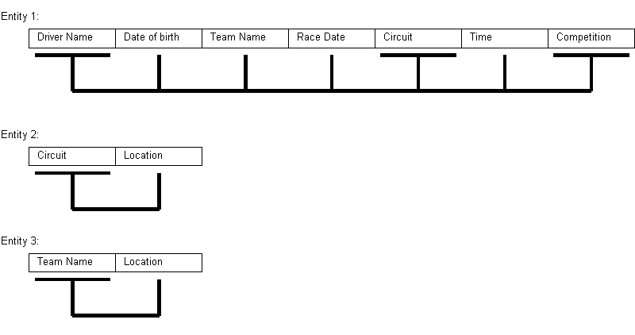
Entities 2 and 3 are already in BCNF so require no more work. These entities will be the “Circuit” and “Team” entities. Entity 1 is in need of normalisation:

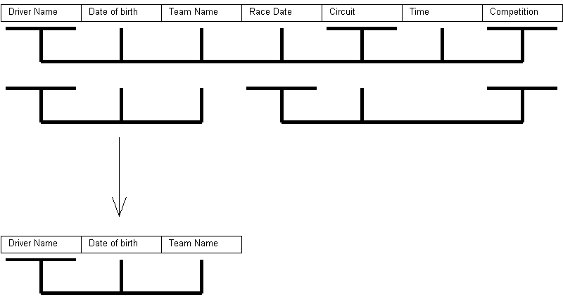
From this initial normalisation we now have another entity in BCNF. This will be the “Driver” entity.

The remaining table still needs further normalisation:
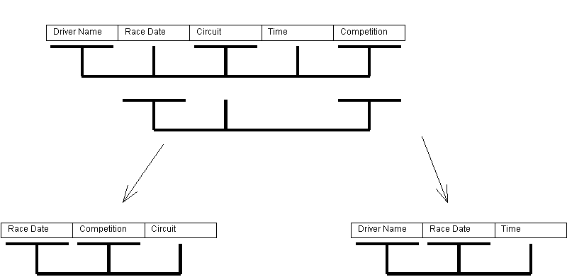
By normalising to this point we now have two entites that are in BCNF. These entites are the “Race” and “Race Record” entity. So the result is 5 BCNF entities:

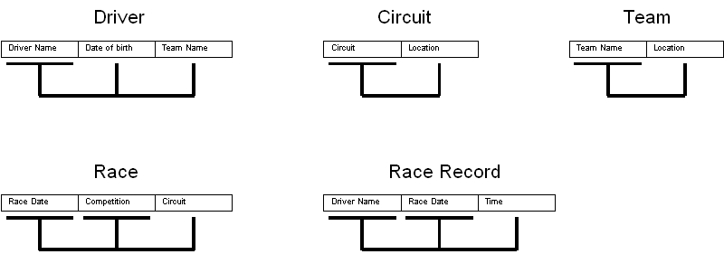
With the above structure we are able to avoid all update, insert and delete anomolies. The only issue I can see with this is that you may want to add a competition without assigning a race to it. That is why I have decided to add an additional entity called “Competition” and have it referenced to in “Race”. With this in mind the final ERI diagram can be constructed.

ERI Diagram:

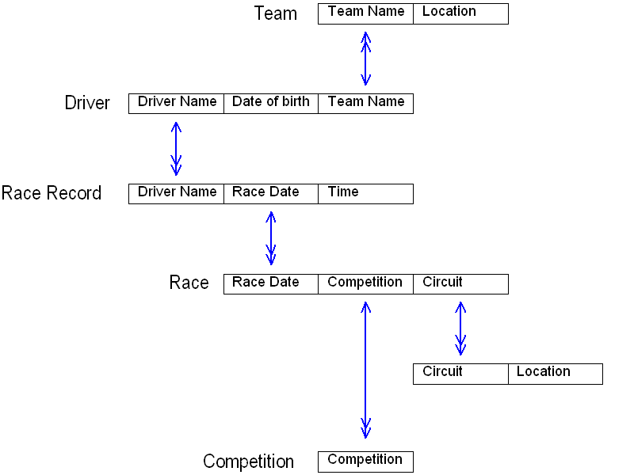

EAR Diagram
Race
Driver
Team
Circuit
Competition
A team may have many drivers

A driver has a race record for every race

Every race record has a race
Race Record
A circuit can host many races

A competition has many races

Details of entity attributes:

Driver(Driver Name, Date of birth,Team Name)
Race Record(Driver Name, Race Date, Time)
Race(Race Date, Competition,Circuit)
Circuit(Circuit Name, Location)
Competition(Competition)
Team(Team Name, Location)

